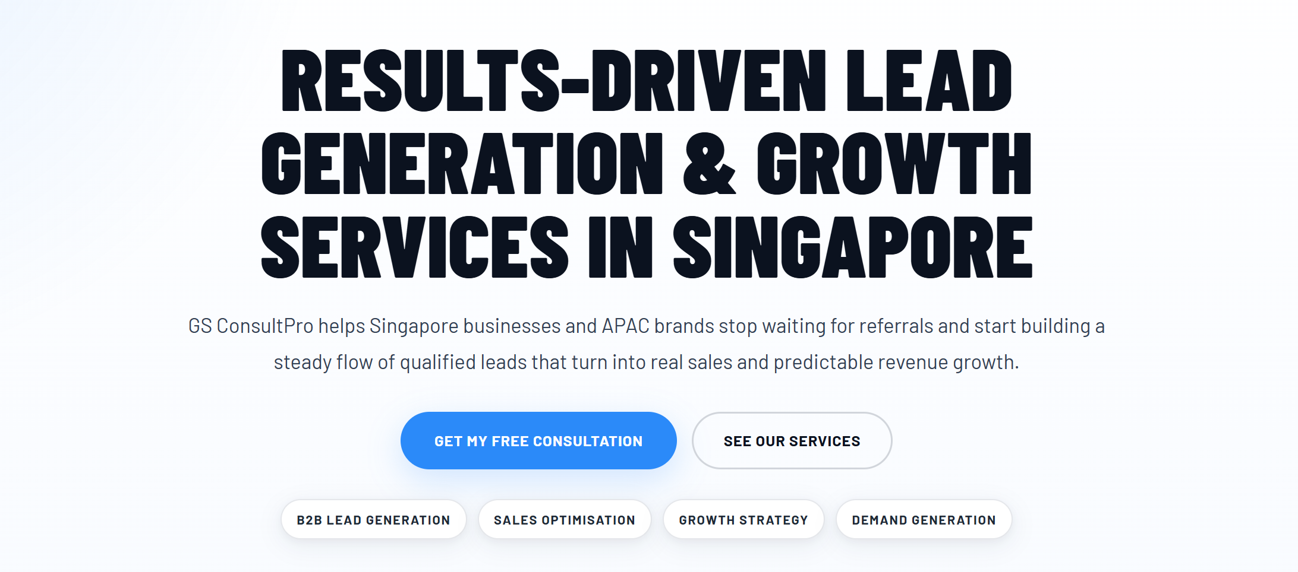
GS ConsultPro helps Singapore businesses and APAC brands strengthen demand generation, improve lead acquisition, and create a more consistent pipeline for business growth.

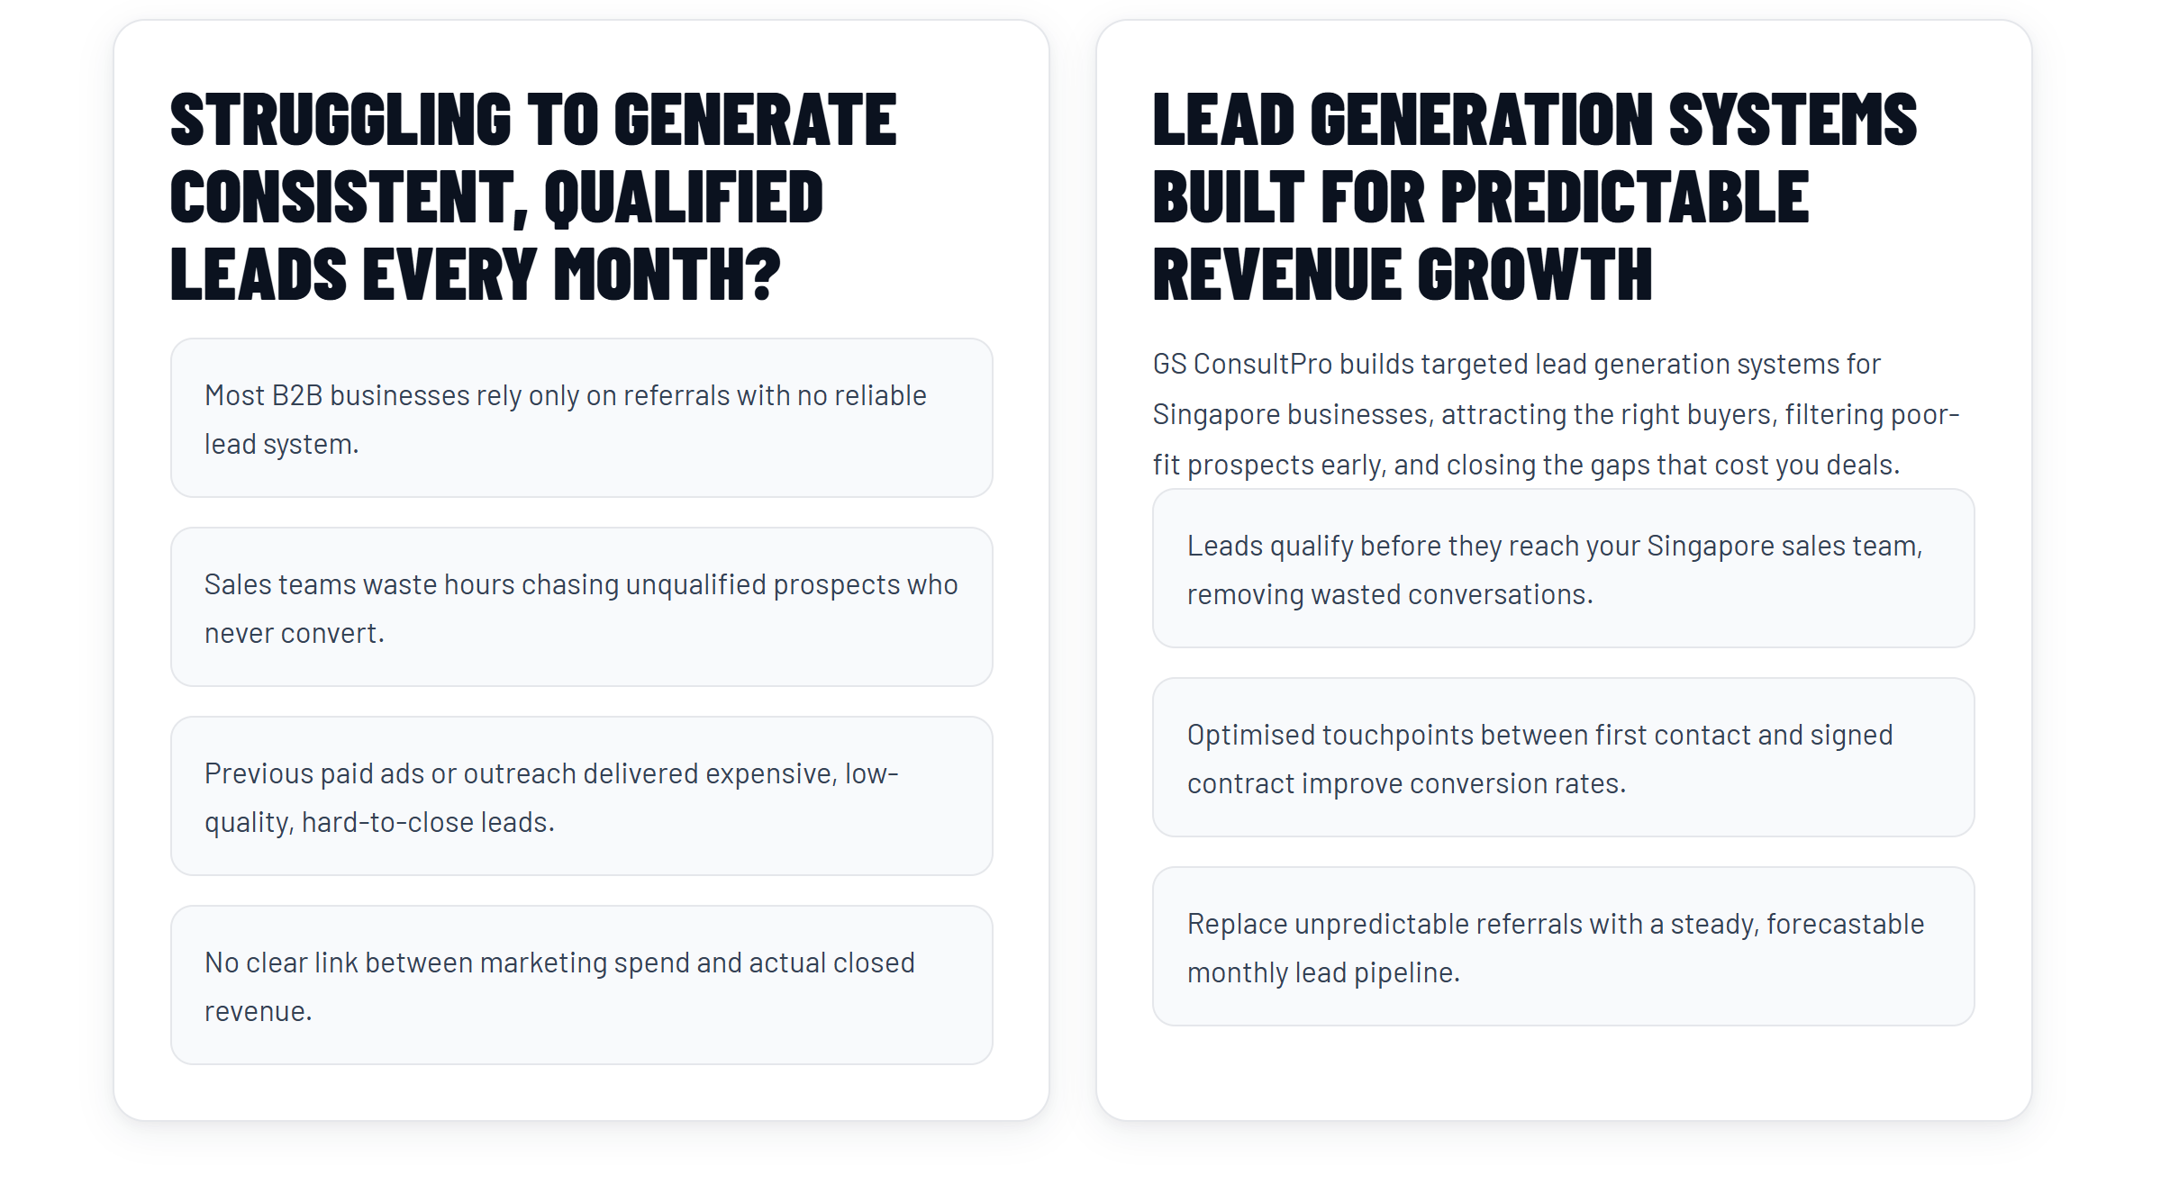
Left Heading: STRUGGLING TO GENERATE CONSISTENT, QUALIFIED LEADS EVERY MONTH?
Left Intro:
Many B2B businesses rely heavily on referrals without a scalable lead generation and sales automation process to support predictable growth.
Left Cards:
- Sales teams waste hours chasing unqualified prospects who never convert.
- Previous paid ads or outreach delivered expensive, low-quality, hard-to-close leads.
- No clear link between marketing activity and actual closed revenue.
Right Heading:
LEAD GENERATION SYSTEMS DESIGNED FOR PREDICTABLE REVENUE GROWTH
Right Intro:
GS ConsultPro helps businesses automate lead generation and sales workflows through targeted outreach, connected systems, and conversion-focused engagement strategies.
Right Cards:
- Leads qualify before they reach your sales team, reducing wasted conversations.
- Automated touchpoints between first contact and signed contract improve conversion rates.
- Build a more stable and predictable flow of qualified opportunities through connected lead generation systems.

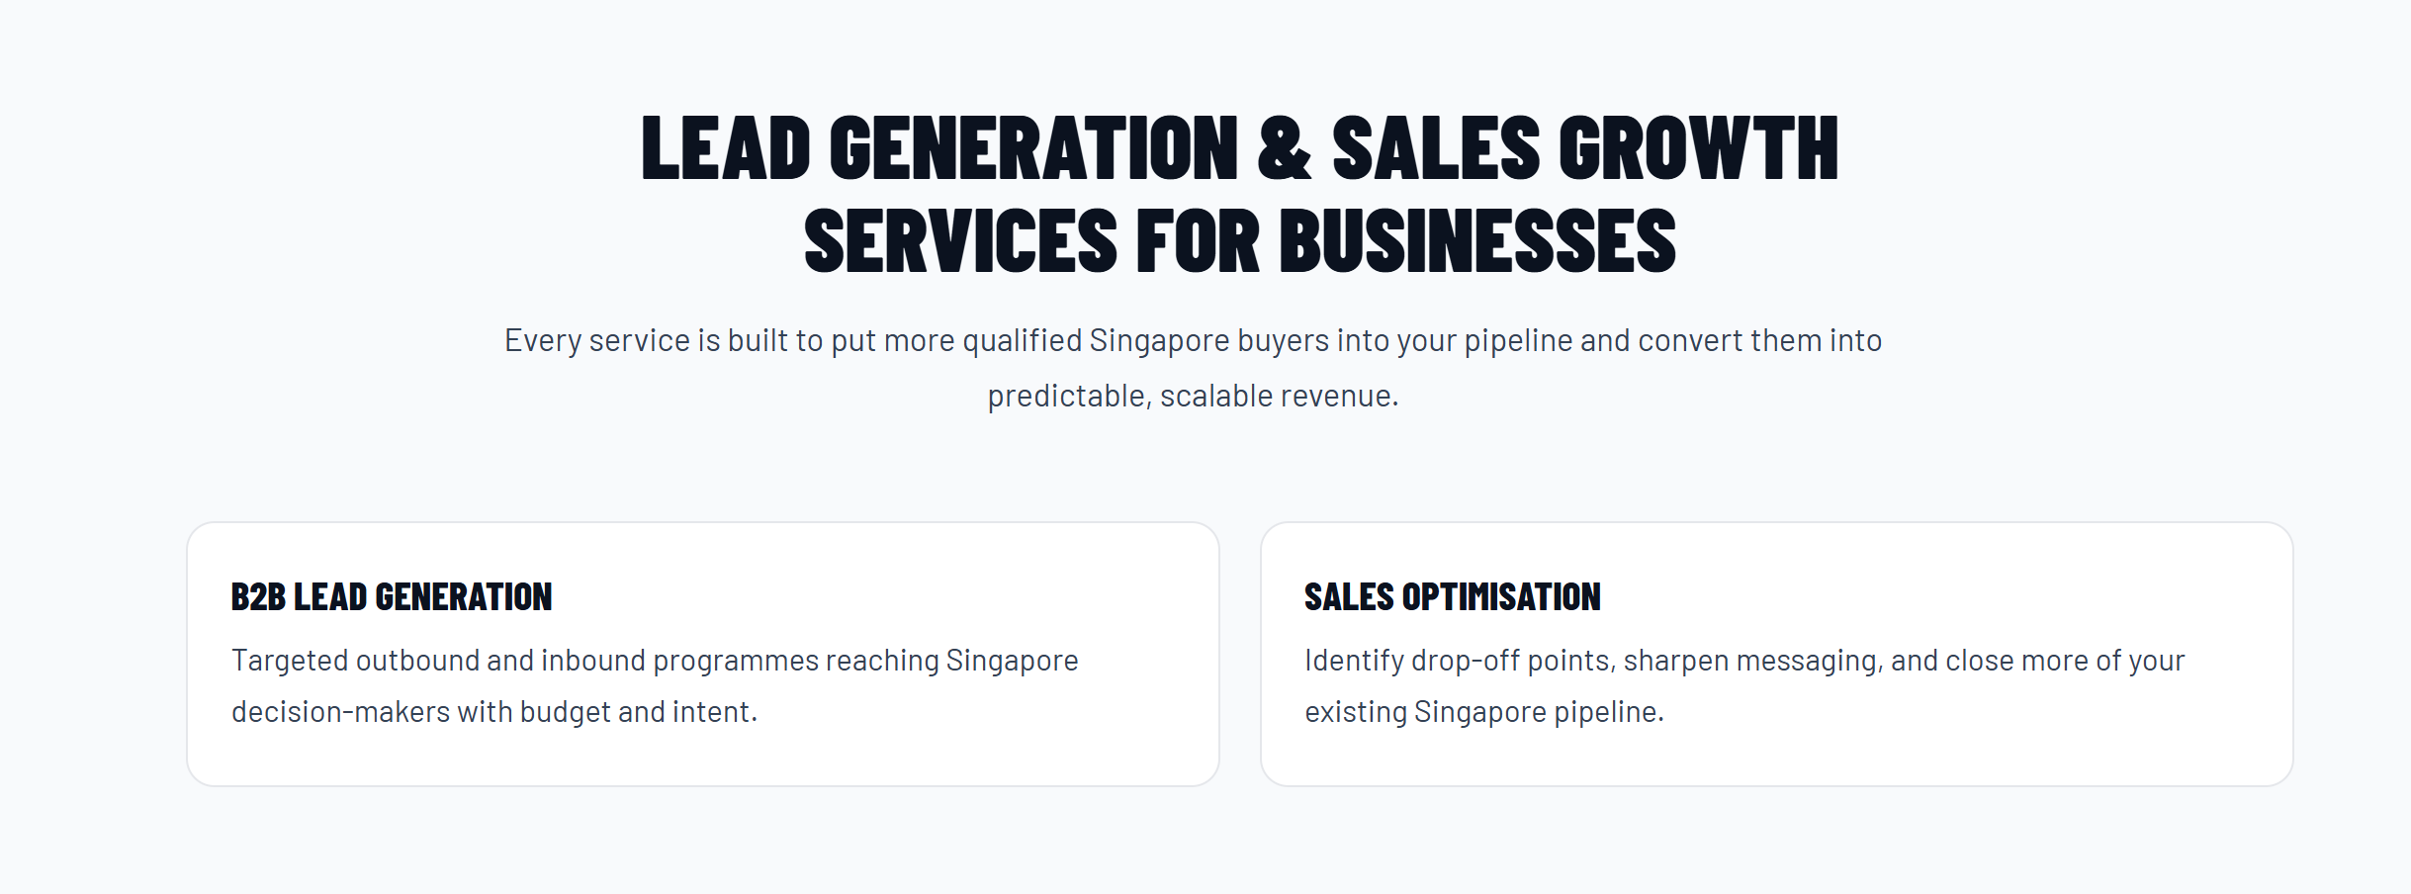
B2B Lead generation does not fit here. This should be under B2B lead gen section. This section talks about automating the process.
Heading: SALES OPTIMISATION & AUTOMATION
Intro: Streamline sales workflows, improve conversion performance, and create more scalable revenue processes.
SALES OPTIMISATION
Improve conversion performance by refining messaging, engagement workflows, and sales touchpoints across the pipeline.
SALES AUTOMATION
Connect outreach, CRM, and lead management systems to streamline qualification, follow-ups, and sales workflows.

Remove this completely:
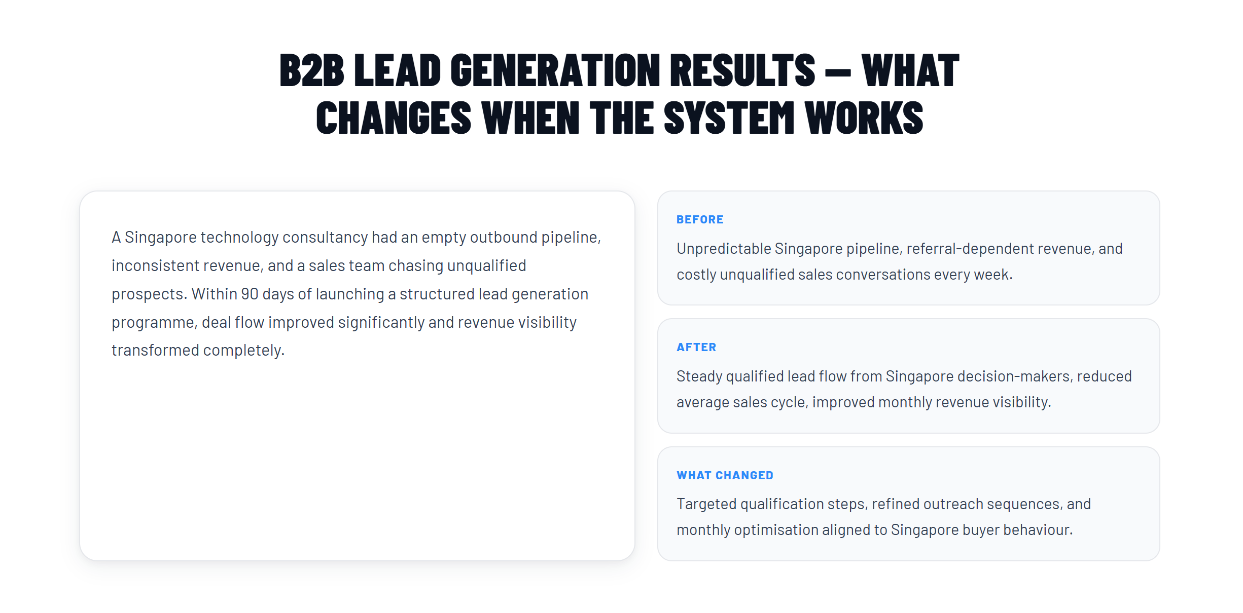
Reason: case-study without proof

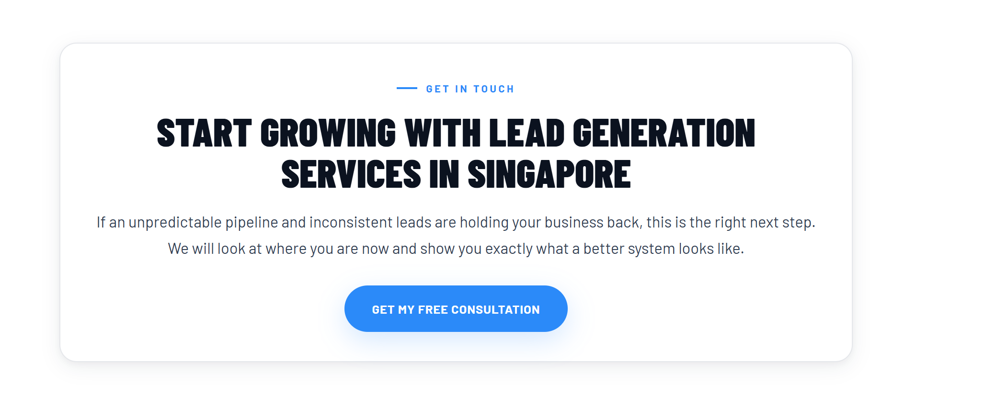
Reason: you already have the stronger blue CTA
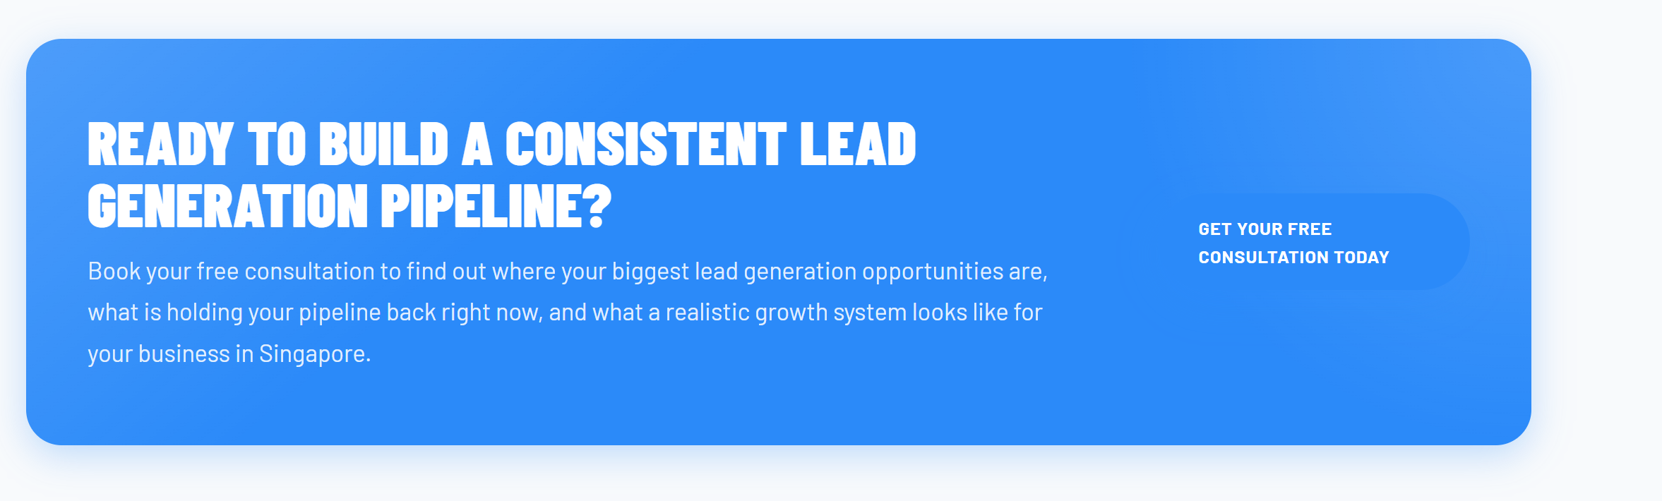
READY TO BUILD A MORE PREDICTABLE GROWTH SYSTEM?
Body:
Book your free consultation to identify workflow gaps, improve lead generation performance, and explore how connected sales and automation systems can support scalable business growth.
CTA: BOOK A FREE CONSULTATION
The button does not show much due to the color. It is blending in.
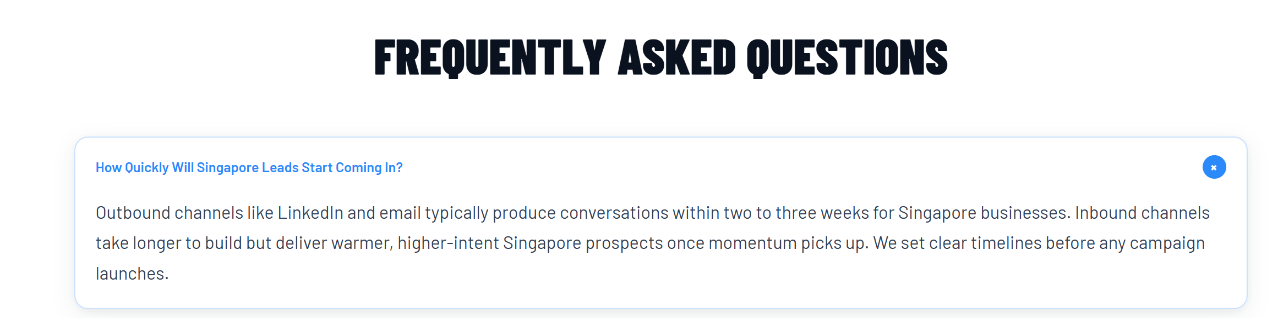
This sounds like B2B lead generation service.
How Quickly Will Systems Start Producing Results?
Initial outreach can begin generating conversations within weeks, while connected systems continue improving qualification, visibility, and conversion performance over time.
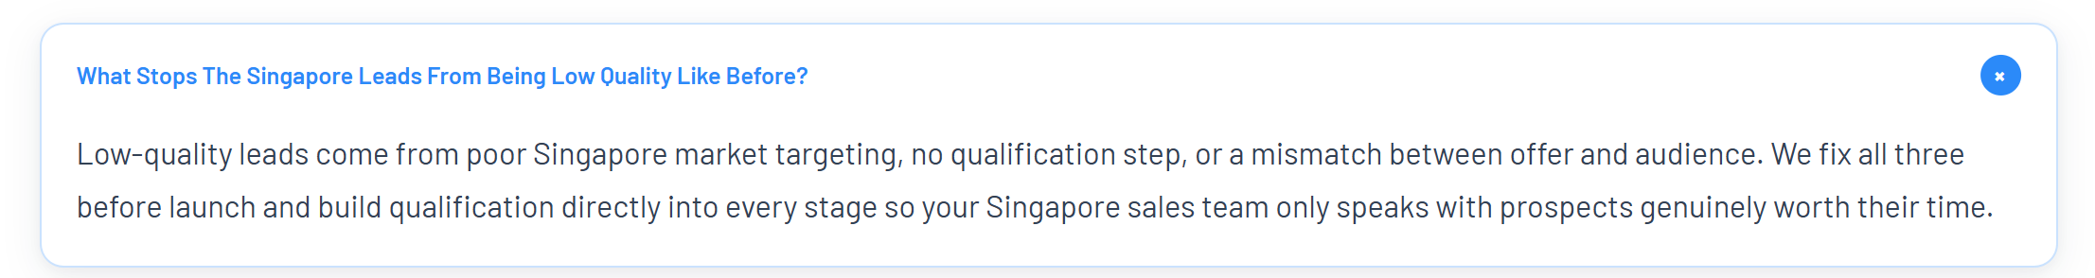
Too much Singapore.
Question:
What Stops Leads From Being Low Quality Like Before?
Answer:
Low-quality leads often come from poor targeting, weak qualification workflows, or disconnected outreach processes. GS ConsultPro improves lead quality by refining targeting, introducing qualification steps, and connecting workflows across outreach, CRM, and follow-up systems.

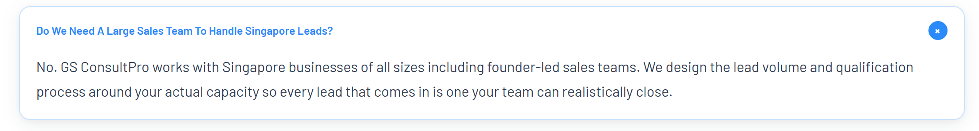

No. GS ConsultPro works with businesses of all sizes. Lead volume, qualification workflows, and follow-up processes are structured around your team’s sales capacity so opportunities can be managed more consistently and efficiently.
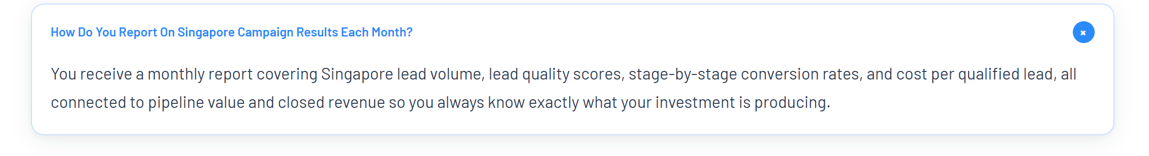
This section is about connecting systems, not providing lead gen services which is under B2B lead gen.

Question:
How Do You Track Performance Across Connected Systems?
Answer:
GS ConsultPro helps businesses centralise visibility across outreach, CRM, qualification, and follow-up workflows so teams can track pipeline activity, response handling, conversion movement, and operational performance more clearly.

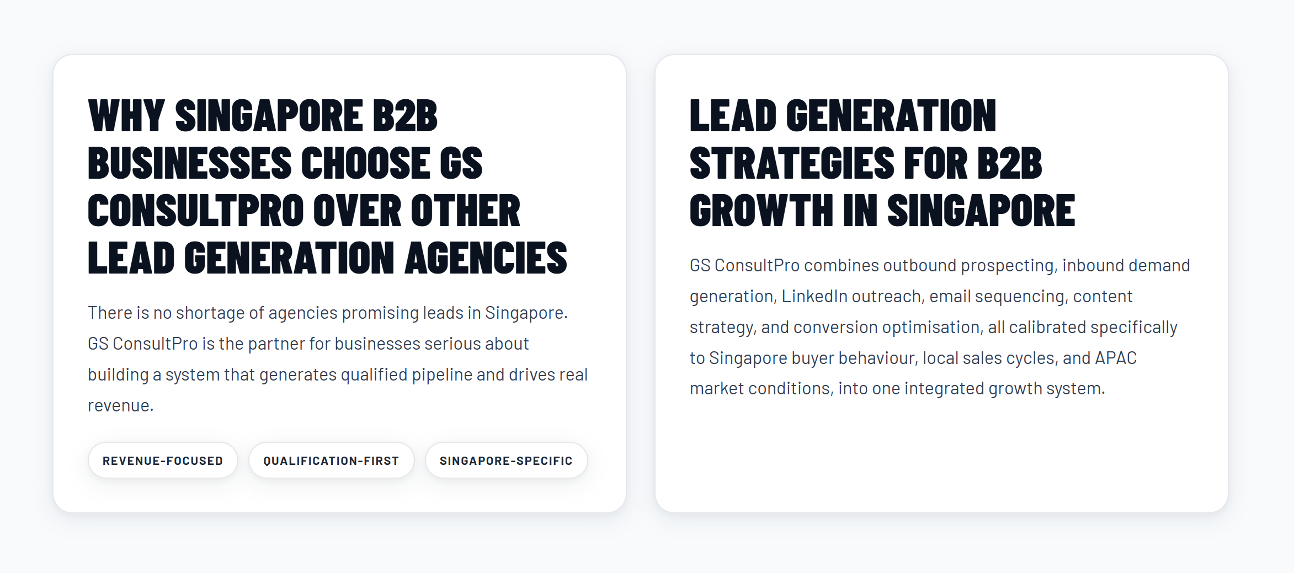

Left Card
Headline: WHY BUSINESSES CHOOSE GS CONSULTPRO FOR CONNECTED SALES SYSTEMS
Many businesses struggle with disconnected sales processes, inconsistent follow-ups, and limited visibility across the customer journey. GS ConsultPro helps create more structured and scalable sales operations through connected workflows and automation.
Tags:
- WORKFLOW-DRIVEN
- AUTOMATION-FOCUSED
- REVENUE-FOCUSED
Right Card
Headline:
CONNECTED SALES & GROWTH WORKFLOWS
GS ConsultPro connects outreach, CRM, qualification, follow-up, and reporting systems into one structured workflow designed to improve lead handling, operational visibility, and sales process efficiency.

This now aligns much better with automation systems, workflow integration etc.

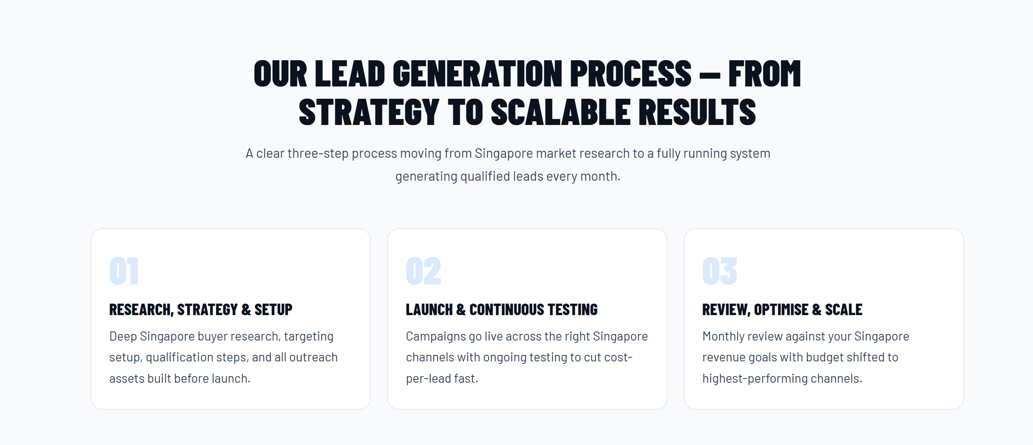
This does not fit here. We are talking about automation in this section.

Headline:
OUR SALES & AUTOMATION PROCESS — FROM STRATEGY TO SCALABLE WORKFLOWS
Intro:
A structured three-step process designed to connect workflows, improve operational visibility, and support scalable sales systems.
Card 1
RESEARCH, STRATEGY & SETUP
Review sales workflows, qualification processes, CRM structure, and operational gaps before configuring connected systems and automation flows.
Card 2
WORKFLOW INTEGRATION & AUTOMATION
Connect CRM, outreach, qualification, follow-up, and reporting workflows across platforms such as HubSpot, Salesforce, LinkedIn, Apollo, and other sales or automation systems based on operational requirements.
Card 3
REVIEW, OPTIMISE & SCALE
Monitor workflow performance, refine operational processes, and improve visibility across the sales pipeline as systems continue scaling.

